STUDENT: David Clarke

PROGRAMME: B.Eng Electrical and Electronic Engineering

SUPERVISOR: Dr D J Holding

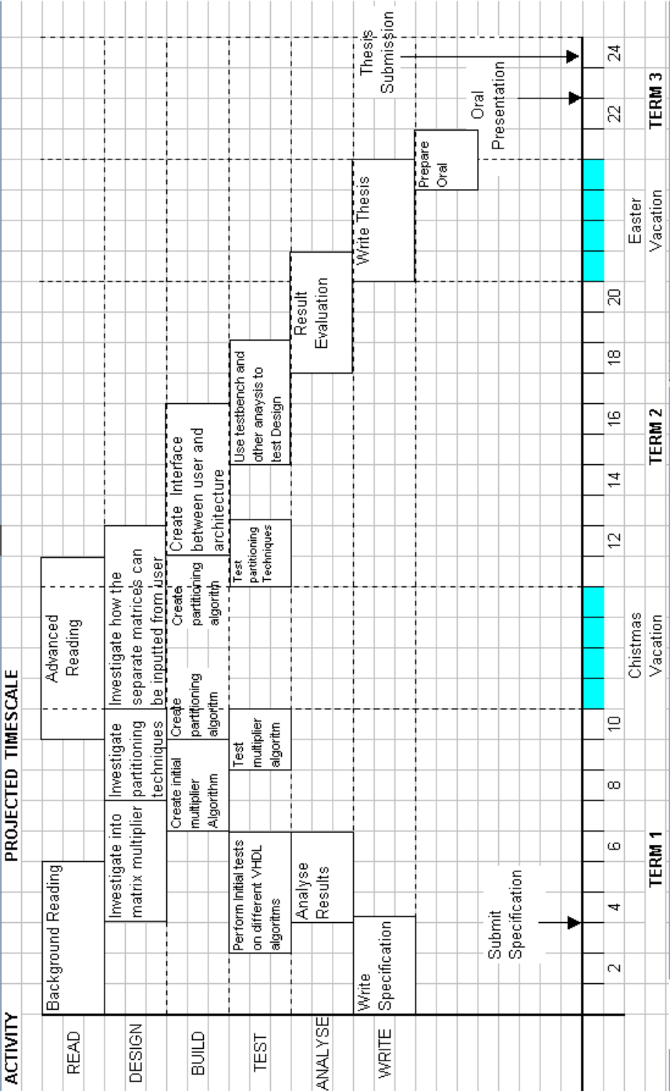

SUPERVISOR [signed] [date]

STUDENT [signed] [date]

